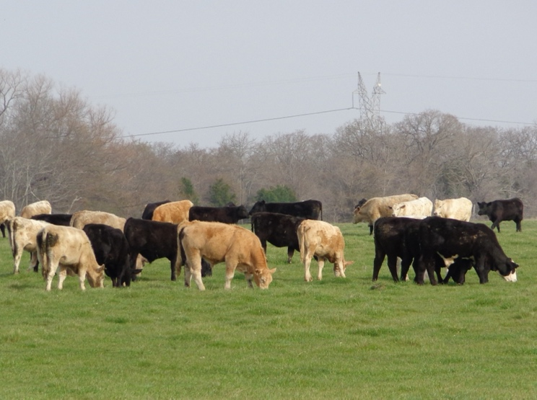****

**Register online at:** <https://tamu.estore.flywire.com/products/reduce-winter-feeding-with-stockpiled-forage-and-winter-pasture-1>

For more information on this program please contact Michelle Sensing @ 903-847-0611.

**Reduce Winter Feeding with**

**Stockpiled Forage and Winter Pasture**

**Online Program: Watch from Home and Save Gas**

**Friday, August 26, 2022**

**Would you prefer to feed hay for 60 days? 100 days? or 150 days?**

**Here’s an opportunity to learn how to significantly reduce your hay feeding needs.**

**Nitrogen fertilizer prices have decreased about 30% from recent highs and continue to trend lower.**

**Winter pasture could be a good option to greatly reduce winter feeding costs.**

**Program presented by:**

Drs. Vanessa Corriher-Olson and Jason Banta

**Topics include:**

* Stockpiled forage: management and utilization
* Acres needed per cow for stockpiled forage and winter pasture
* Cool-season forages and variety selection
* Establishment and fertilization
* Monthly and seasonal forage production potential
* Appropriate mineral supplementation
* Estimated costs

**The program will be divided into 3 sessions to allow attendees to have a break between sessions**

9:00 - 11:00 AM Part 1

12:30 – 2:30 PM Part 2

4:00 – 6:00 PM Part 3

**Register by August 25th at 12:00PM: $35/person**

* Electronic copies of slides and other program materials will be available prior to the program
* All sessions will be recorded and available for later viewing for those that register

Educational programs of the Texas A&M AgriLife Extension Service are open to all people without regard to race, color, religion, sex, national origin, age, disability, genetic information, or veteran status.