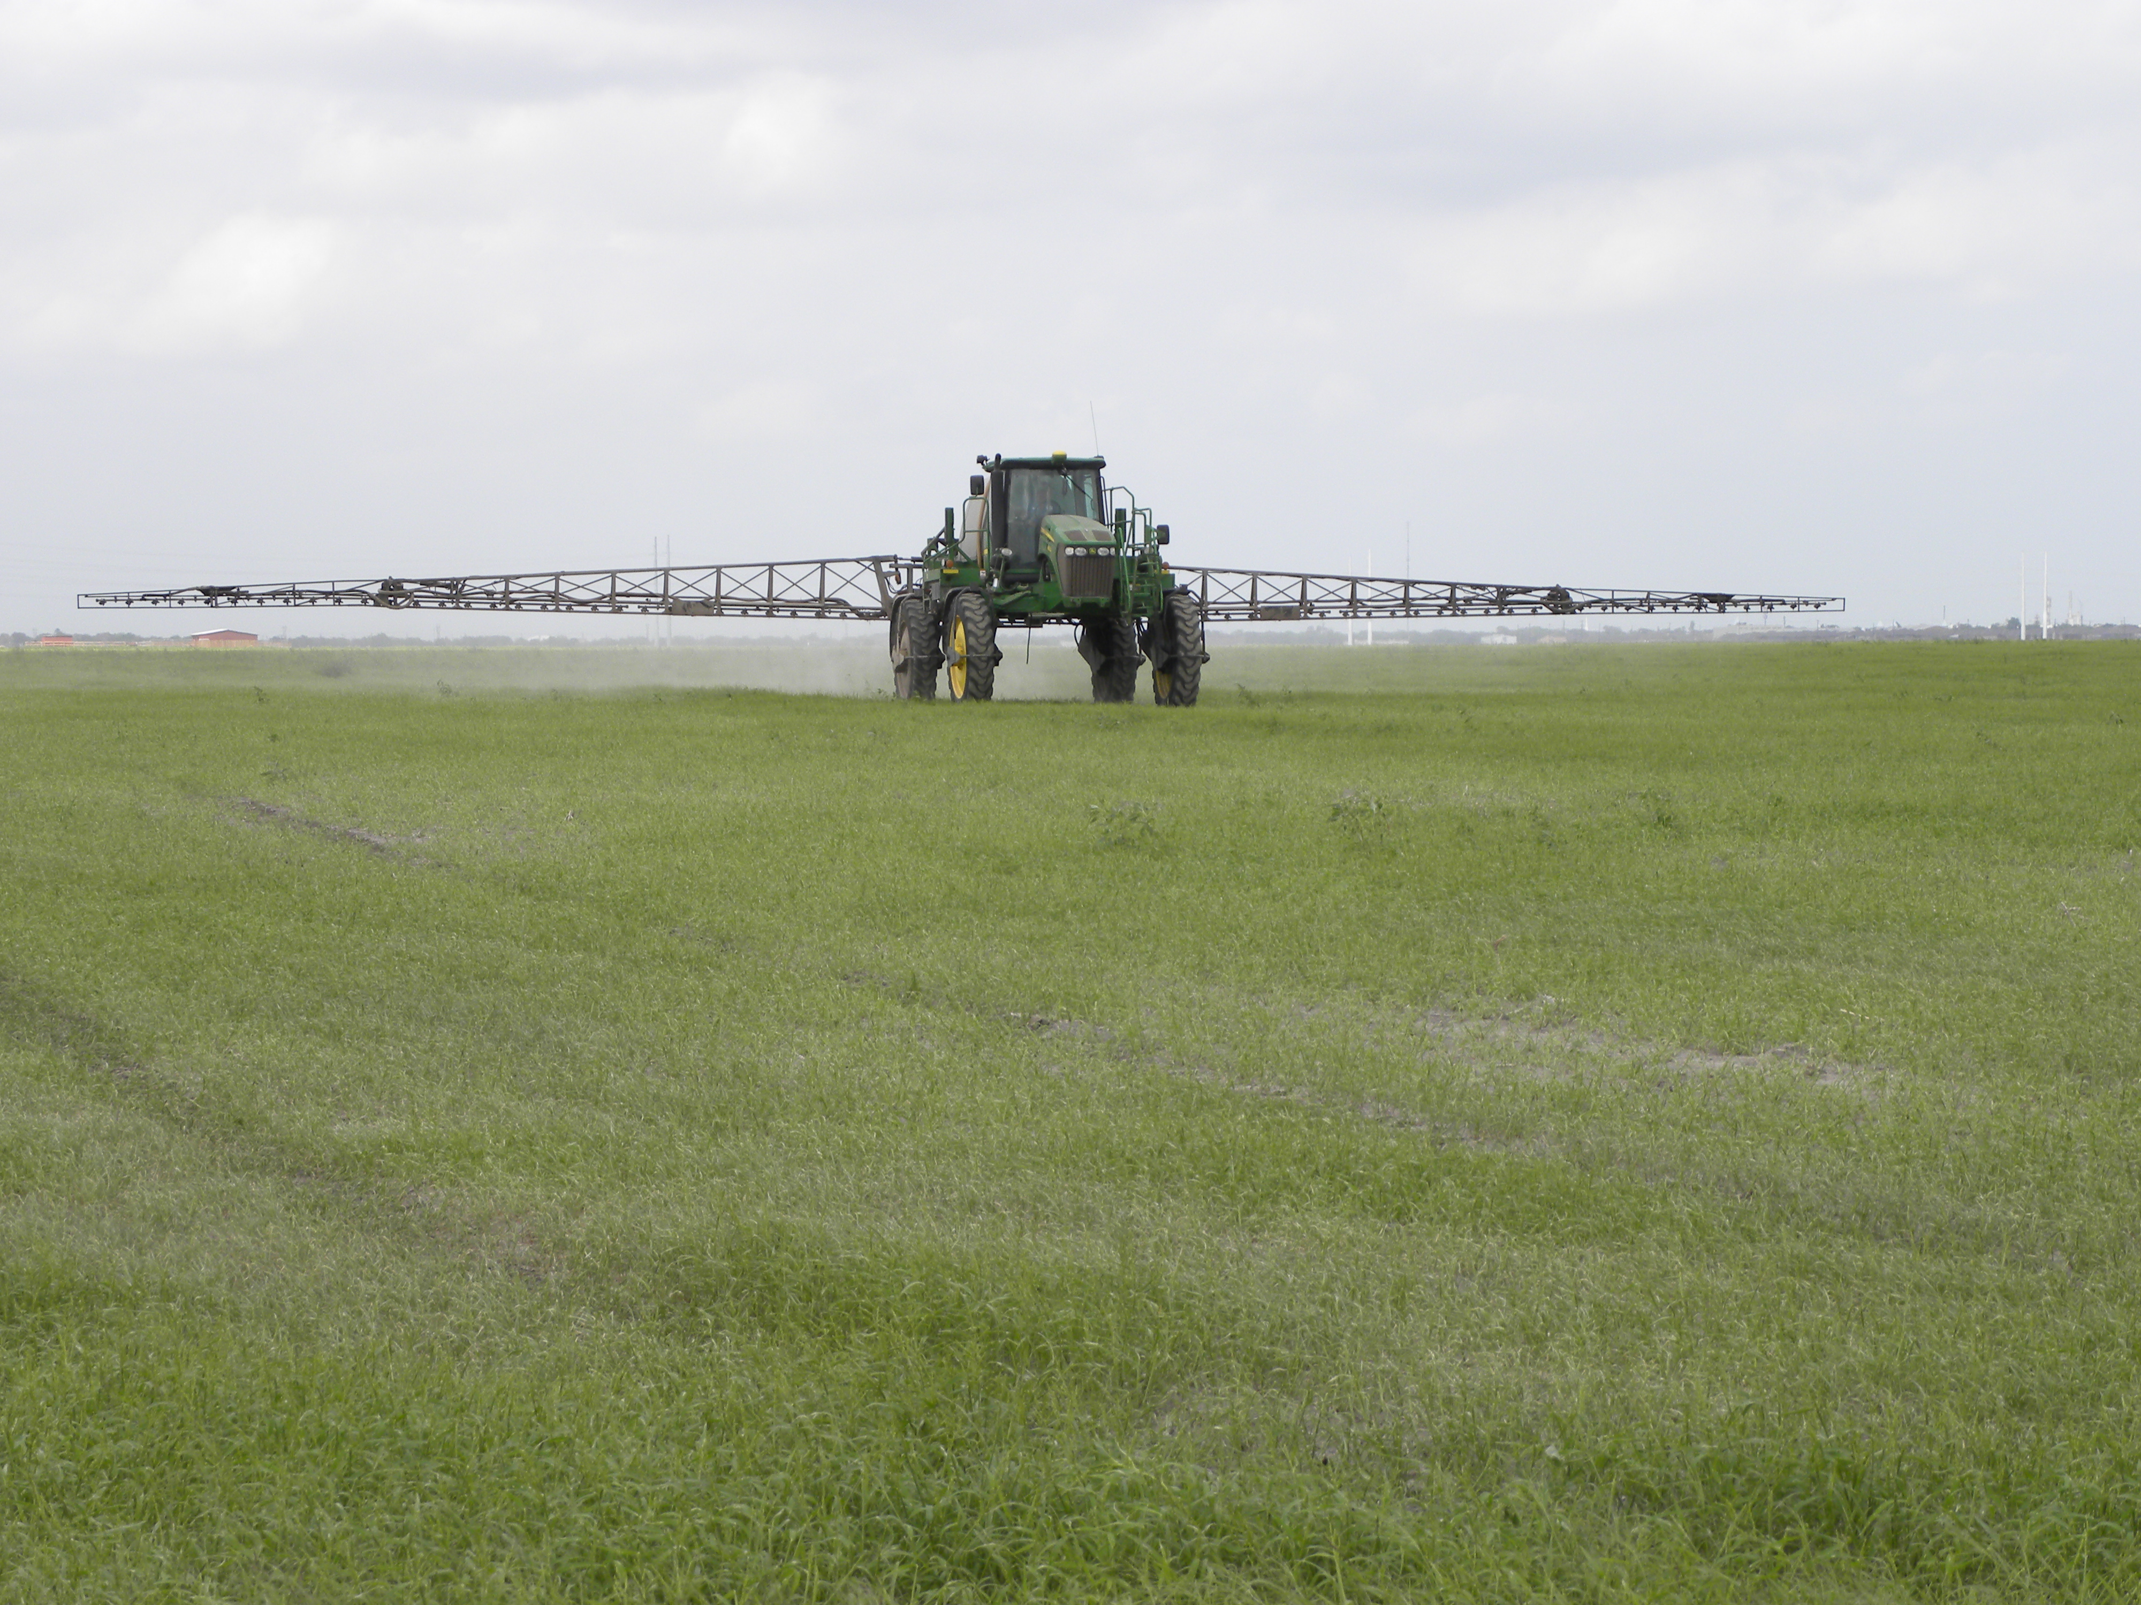****

5 Pesticide CEUs Available Pending TDA Approval

(1 IPM, 1 L&R, 3 Gen)

Must attend both sessions.

* Forage Fertilization Considerations
* Weed Control in Pastures and Hay Meadows
* Laws and Regulations of Pesticide Use
* Effects of Alternative Nutrient Sources on Bermudagrass Production
* Active Ingredients, Application Rates, and Herbicide Costs

Two practices sessions will be held on Thursday February 19 to allow attendees the chance to connect to zoom and make sure all technology is working.

**The program will be divided into 2 sessions to allow attendees to have a break between sessions**

9:00 AM – 12:00 PM

1:30 PM – 3:30 PM

For more information on this program please contact Michelle Sensing@ 903-834-6191.

**Registration Cost: $25/ person**

deadline February 18, 2020 at 1:00 PM

**Register online at:** [https://agriliferegister.tamu.edu/Overton](https://agriliferegister.tamu.edu/organizationListings/161)

or call Extension Conference Services @ 979-845-2604

**East Texas Pasture Management**

**Friday, February 19, 2021**

**Online Program**

Soil & Crop Sciences Department

Department of Animal Science

Educational programs of the Texas A&M AgriLife Extension Service are open to all people without regard to race, color, sex, disability, religion, age, or national origin.