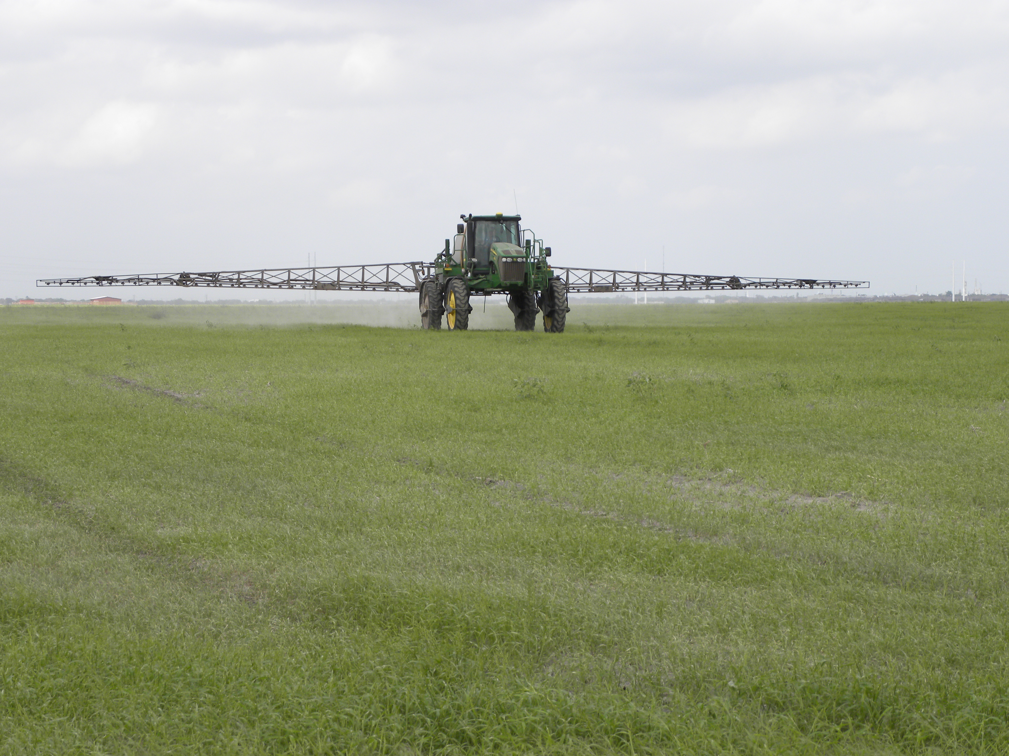****

**Register online at:** [https://agriliferegister.tamu.edu/Overton](https://agriliferegister.tamu.edu/organizationListings/161)

or call Extension Conference Services @ 979-845-2604

8:30 Program starts

11:45 Lunch served

3:00 Adjourn

Visit Booths of Local Pesticide and

Other Agricultural Companies

For more information on this program please contact Pam Hickman @ 903-834-6191.

* Weed Control Strategies for Pastures and Hay Fields
* Wild Pig Control
* Aquatic Weed Control
* External Parasite Control

5 Pesticide CEUs Available

(1 laws, 1 IPM, and 3 general)

Course # 0817367

**Preregistration Cost: $35/ person**

deadline Sunday, November 30, 2019

Extension Conference Services must receive payment by December 2

**On-Site Registration Cost: $60/person**

**Pesticide Applicators Training**

**Thursday, December 5, 2019**

Texas A&M AgriLife Research and Extension Center

1710 N. Hwy 3053, Overton, TX 75684

Soil & Crop Sciences Department

Department of Animal Science

Educational programs of the Texas A&M AgriLife Extension Service are open to all people without regard to race, color, sex, disability, religion, age, or national origin.