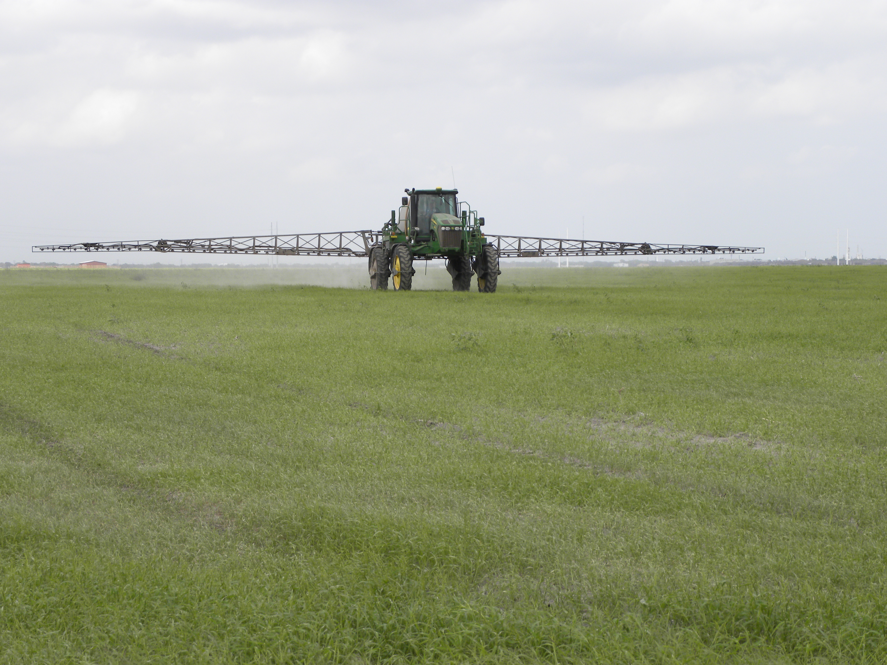****

Sponsorship support provided by:

* Spraying Equipment
* Soil Fertility & Fertilizers
* Drift Management
* Laws & Regulations of Pesticide Use
* Save Money by Understanding Active Ingredients, Residual Control and Herbicide cost

5 Pesticide CEUs Available

(Pending Approval)

Visit Booths of Local Pesticide and

Other Agricultural Companies

For more information on this program please contact Michelle Sensing@ 903-834-6191.

1:00 Program starts

6:00 Adjourn

**Register online at:** [https://agriliferegister.tamu.edu/Overton](https://agriliferegister.tamu.edu/organizationListings/161)

or call Extension Conference Services @ 979-845-2604

**Preregistration Cost: $25/ person**

deadline February 20, 2019

Extension Conference Services must receive payment by February 20

**On-Site Registration Cost: $35/person**

**East Texas Pasture Management**

**Friday, February 22, 2019**

Texas A&M AgriLife Research and Extension Center

1710 N. Hwy 3053, Overton, TX 75684

Soil & Crop Sciences Department

Department of Animal Science

Educational programs of the Texas A&M AgriLife Extension Service are open to all people without regard to race, color, sex, disability, religion, age, or national origin.