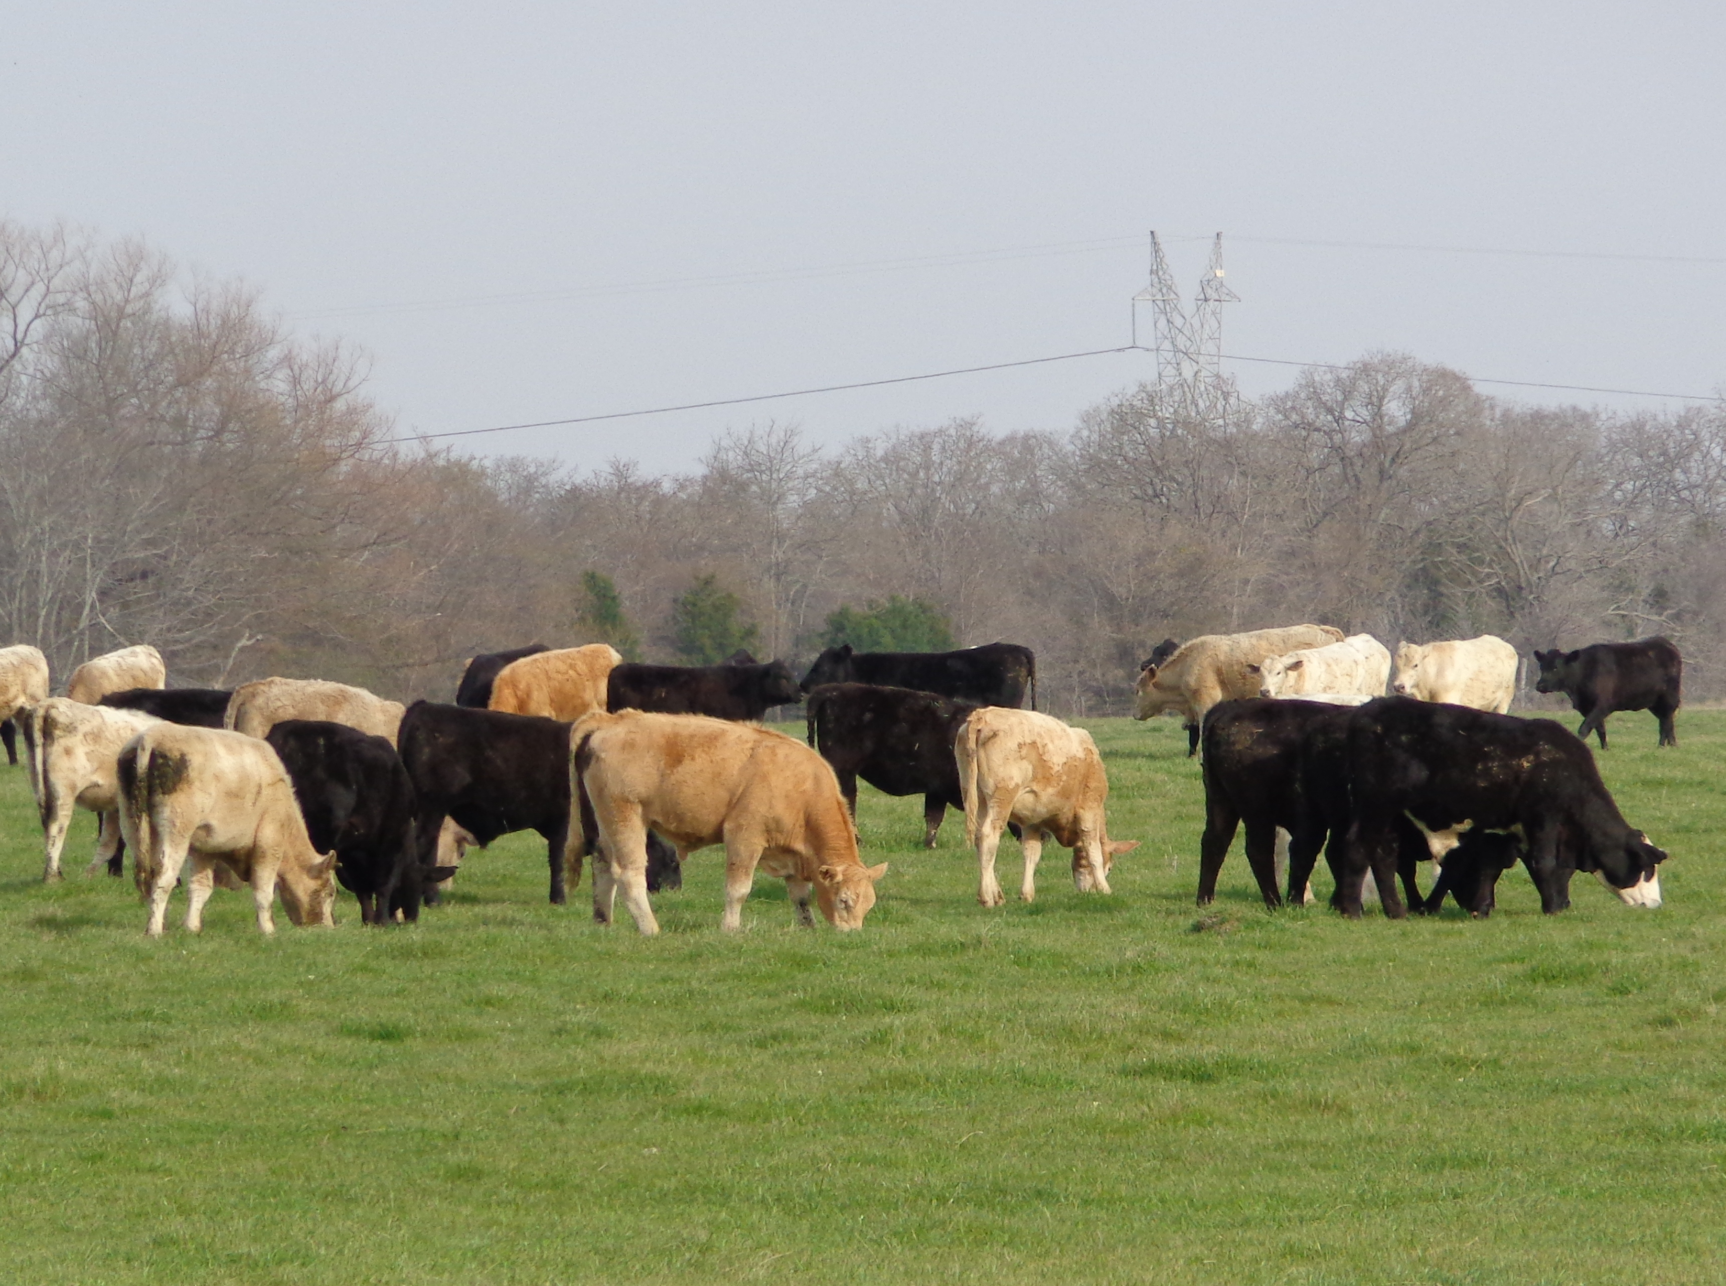****

**Thursday, August 24, 2017**

Texas A&M AgriLife Research and Extension Center

1710 N. Hwy 3053, Overton, TX 75684

**Would you prefer to feed hay for 60 days? 100 days? or 150 days?**

**Here’s an opportunity to learn how to significantly reduce your hay feeding needs.**

Program presented by:

Drs. Vanessa Corriher-Olson and Jason Banta

Topics include:

* Stockpiled forage: management and utilization
* How many acres do you need of stockpiled forage and winter pasture?
* Cool-season forages and variety selection
* Establishment and fertilization
* Monthly and seasonal forage production potential
* Appropriate mineral supplementation
* Estimated costs

**9:30 Registration starts**

**10:00 Program starts**

**12:00 Lunch served**

**5:00 Adjourn**

**Register online at:** [**https://agriliferegister.tamu.edu**](https://agriliferegister.tamu.edu)**;**

or call Extension Conference Services @ 979-845-2604

**Register before August 13th: $60/ person**

Register before August 22nd: $75/person

Money back guarantee

(Includes lunch and program materials)

For more information on this program please contact Michelle Sensing @ 903-834-6191.

*2 Pesticide CEUs Available (1 IPM and 1 general)*

Educational programs of the Texas A&M AgriLife Extension Service are open to all people without regard to

race, color, religion, sex, national origin, age, disability, genetic information, or veteran status.

**Reduce Winter Feeding with Stockpiled Forage and Winter Pasture**