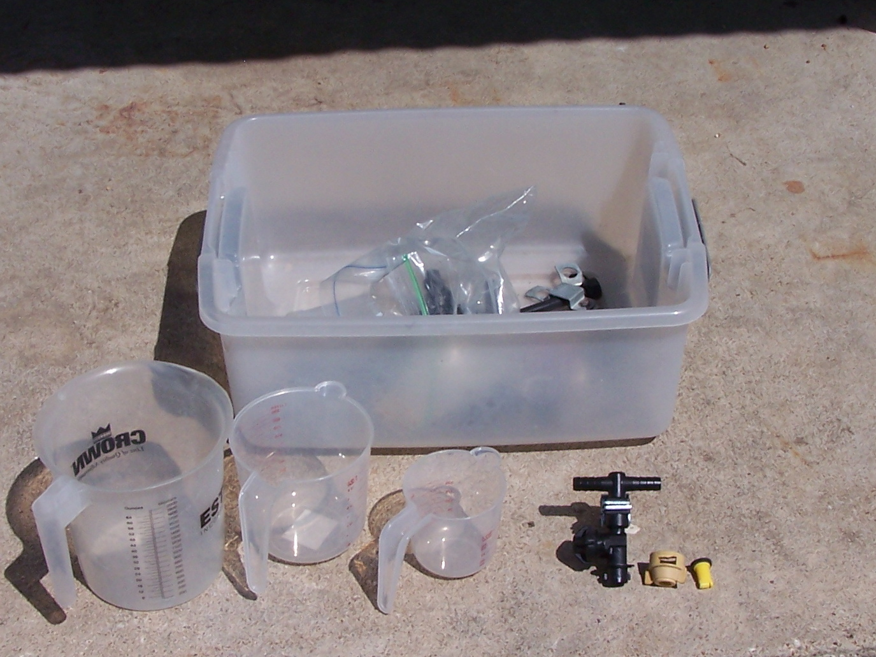******

*Visit Booths of Local Pesticide and Other Agricultural Companies*

*5 Pesticide CEUs Available (1 laws, 1 IPM and 3 general)*

**Register online at:** [**https://agriliferegister.tamu.edu**](https://agriliferegister.tamu.edu)**;**

or call Extension Conference Services @ 979-845-2604

* Effective weed control with weed identification, proper timing and herbicide selection
* Sprayer tip selection and equipment calibration
* Using herbicides under trees: Is it possible?
* Does storage of pesticides impact efficacy?
* How to properly dispose of empty containers and old pesticides

**Preregister by Feb. 19, 2015: Cost: $25/ person**

**On-Site Registration Cost: $35/person**

(Includes 2015 Herbicide Price Comparison CD)

**12:30 Registration starts**

**1:00 Program starts**

**6:00 Adjourn**

For more information on this program please contact Michelle Sensing @ 903-834-6191.

A herbicide price comparison CD, updated for 2015, will be provided to help you make more economical choices when it comes to selecting a herbicide. **During this half a day program** **Drs. Vanessa Corriher-Olson, Jason Banta, Paul Baumann and Mark Matocha will cover the following topics:**

**Friday, February 20, 2015**

**Texas A&M AgriLife Research and Extension Center**

**1710 N. Hwy 3053, Overton, TX 75684**

**East Texas Pasture Management Program**

Educational programs of the Texas A&M AgriLife Extension Service are open to all people without regard to race, color, sex, disability, religion, age, or national origin.