East Texas Pasture Management Program

February 20, 2015

Texas A&M AgriLife Research and Extension Center
1710 N. Hwy 3053, Overton, TX

5 Pesticide CEUs Available
(1 laws, 1 IPM, and 3 general; TDA Course#0688616)

Preregister by Feb 19, 2015; Cost: $25/ person
Register at: https://agriliferegister.tamu.edu; Keyword: pasture
Registration includes a 2015 Herbicide Price Comparison CD
On-Site Registration Cost: $35/person

12:30 Check in and Registration

1:00 Does storage of pesticides impact efficacy? & How to Properly Dispose of Empty Containers and Old Pesticides (Dr. Mark Matocha, Assistant Professor and Extension Specialist)

2:00 Using Herbicides Under Trees: Is it Possible? (Dr. Paul Baumann, Professor and Extension Weed Specialist)

3:00 Break (coffee, bottled water, and snack provided)

3:10 Spray Tip Selection and Equipment Calibration (Dr. Paul Baumann)

4:10 Effective Weed Control with Weed Identification, Proper Timing and Herbicide Selection (Dr. Vanessa Corriher-Olson, Associate Professor and Extension Forage Specialist)

5:30 How to Use the Herbicide Cost Comparison CD (Dr. Jason Banta, Associate Professor and Extension Beef Cattle Specialist)
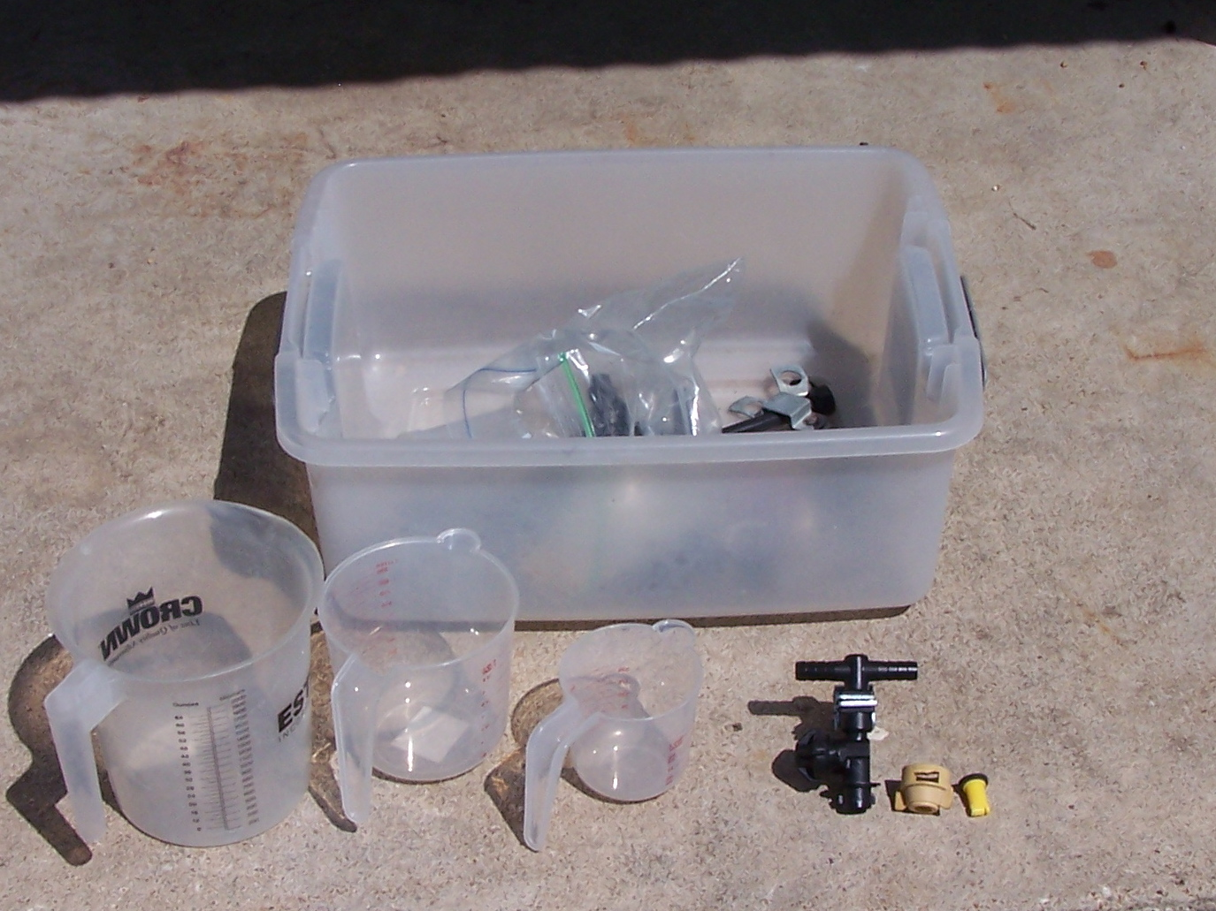
6:00 Adjourn

A herbicide price comparison CD, updated for 2015, will be provided to help you make more economical choices when it comes to selecting a herbicide.

For more information on this program please contact Michelle Sensing @ 903-834-6191.
Educational programs of the Texas A&M AgriLife Extension Service are open to all people without regard to race, color, sex, disability, religion, age, or national origin.

