

**Thursday, December 4, 2014**

**Texas A&M AgriLife Research and Extension Center**

**1710 N. Hwy 3053, Overton, TX 75684**

**Pesticide Applicator Training**

**~2 Events~**

**10 CEUs**

Educational programs of the Texas A&M AgriLife Extension Service are open to all people without regard to race, color, sex, disability, religion, age, or national origin.

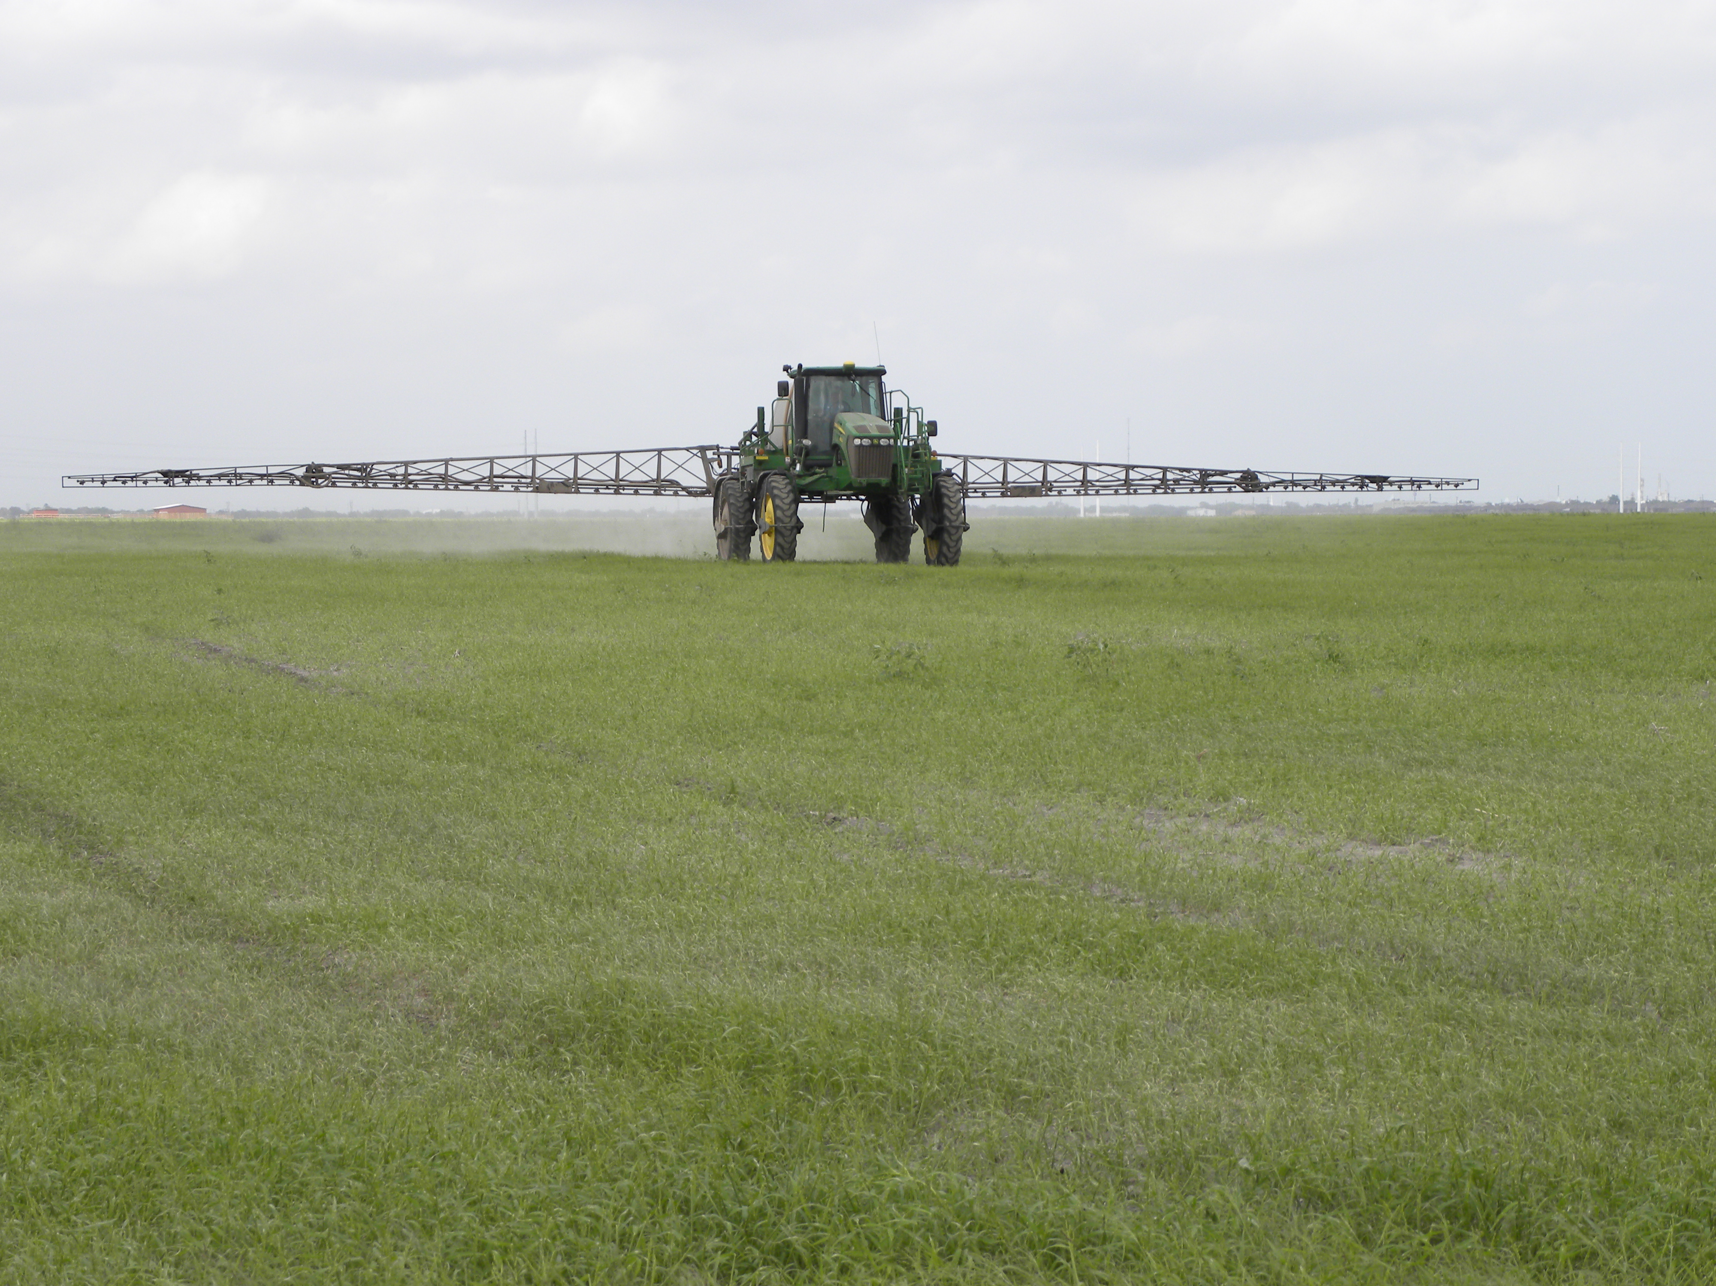

* Weed control in pastures and hay meadows
* Regulations for pesticide treatment of aquatic environments
* Beef cattle external parasite control
* Appropriate stocking rate to reduce weed populations
* Wild Pig Control

**On Site Registration**

**Cost: $30/ person**

(includes lunch)

**Tuesday, December 9, 2014**

**Texas A&M AgriLife Research and Extension Center**

**1710 N. Hwy 3053, Overton, TX 75684**

**7:30 Registration starts**

**8:30 Program starts**

**11:45 Lunch served**

**3:00 Adjourn**

*5 Pesticide CEUs Available*

*(1 Laws & Regulations; 2 IPM & 2 general)*



For more information on this program please contact Pam Hickman @ 903-834-6191.

***************************************************************************************************

* Texas Department of Agriculture Laws & Regulations
* Integrated pest management
* Insect and disease issues and management – urban and suburban trees
* Turf diseases and pests
* Turf Weed Management

*5 Pesticide CEUs Available*

*(1 Laws & Regulations; 2 IPM & 2 general)*

**7:30 Registration starts**

**8:30 Program starts**

**11:45 Lunch served**

**3:00 Adjourn**

**On Site Registration**

**Cost: $30/ person**

(includes lunch)